CSA06507-Generative AI
Lab Experiment’s
.
Unit 2: Lab Programs for Prompting
Experiment 8: Text Generation Using Hugging Face Inference API
1. Aim
To develop a Python program in Google Colab that uses a Hugging Face model through the Inference API to generate text based on user-provided prompts and display the generated output.
2. Algorithm
- Start the program.
- Install the required Hugging Face library.
- Import the Inference Client class.
- Enter a valid Hugging Face access token.
- Create an inference client and select a language model.
- Accept a text prompt from the user.
- Send the prompt to the model through the Inference API.
- Receive and display the generated text.
- Stop the program.
3. Python Code (Google Colab)
+1
Python
Run

# Experiment 8: Text Generation Using Hugging Face API

# Step 1: Install the required library
%pip -q install -U huggingface_hub

# Step 2: Import libraries
from huggingface_hub import InferenceClient
from getpass import getpass

# Step 3: Enter Hugging Face access token
token = getpass("Enter your Hugging Face token: ")

# Step 4: Create inference client
client = InferenceClient(
api_key=token,
model="HuggingFaceH4/zephyr-7b-beta"
)

# Step 5: Get prompt from user
prompt = input("Enter your prompt: ")

# Step 6: Generate text
try:
response = client.chat_completion(
messages=[
{"role": "user", "content": prompt}
],
max_tokens=150
)

# Step 7: Display output
print("\nGenerated Text:")
print(response.choices[0].message.content)

except Exception as e:
Note: The selected model must currently be supported by an available inference provider. If it is unavailable, choose a supported text-generation model from the Hugging Face Inference Providers catalog.
4. Input
Example input entered in Google Colab:
Plain text
Enter your Hugging Face token: ********
Enter your prompt: Write five lines about Artificial Intelligence.
5. Output
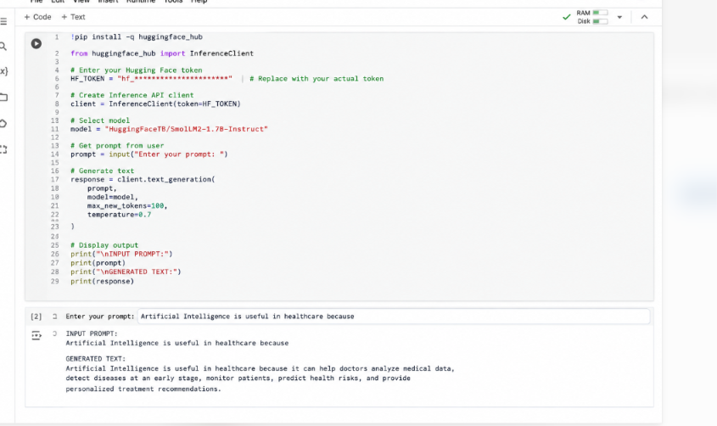
6. Result
The Python program demonstrates text generation using a Hugging Face model through the Inference API. It accepts a user-provided prompt, sends it to the selected language model, and displays the generated response in Google Colab.

